Big Thunderstorm Downpour On My Mountain
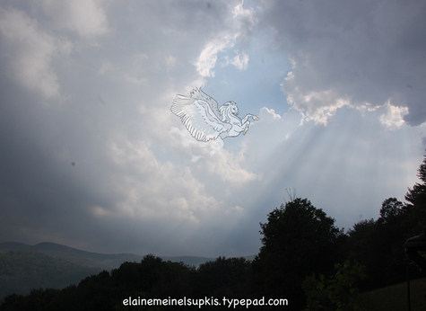
July 11, 2008
Elaine Meinel Supkis
We had this terrific downpour the other day. I ran out after this one hour storm dumped over 3 1/2" of rain on us and took pictures of the house my family and I built with our own hands over the years. Time to look at a house made from scavenged materials, trees we milled on a small wood mill, odds and ends of various sorts. The house was designed by myself with no blueprints, not plans at all. Just step by step, as I got materials, I used them. This house is very, very strong and extremely solid. For the wood is big and wide and the trees were selected by myself, in the forest.
Trees growing on mountainsides have smaller rings and are of sounder wood than trees that grow in swampy areas or have less pressure from the prevailing winds. Trees that fight for life on mountainsides are strong because of adversity. This is true throughout all of Nature: if something is sheltered and never has to struggle to survive, it is weak and sickly.
This is why we must face the winds and storms of life and be brave and good. Even if this doesn't seem to be as beneficial as screwing your neighbors, stealing stuff and running murderous regimes, in the long run of history, goodness shines through like sunlight through stained glass windows in ancient cathedrals.
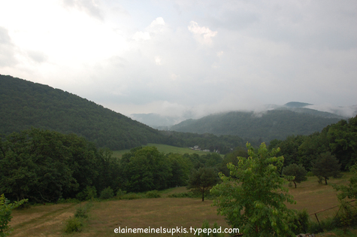
This was the end of the storm. It was a very small storm but extremely powerful. It it lasted more than an hour, it would have destroyed much of my community. As it was, this unleashed a sufficient flood that it nearly washed out our roads. It certainly did make a big mess of all the roads on the side of my mountain including my own.
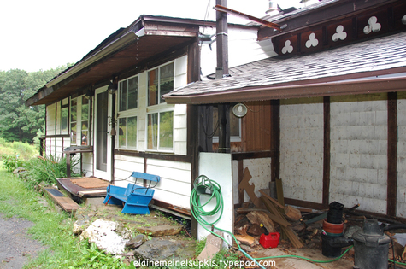
My front door faces north, towards the mountainside. The storage area for the winter firewood is on the right, by the hoses. I deliberately designed the front door to be insignificant because the surprise is when one walks into the house.
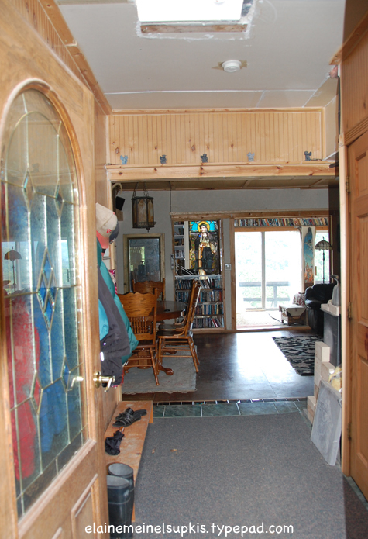
The view from the entryway runs straight to the southern sun room which has several sliding glass doors looking out upon the huge landscape of the village of Berlin below as well as the surrounding tumbled, steep hillsides to the south. Also, there is the stained glass window which was damaged in an earthquake and which I got all the pieces together and rebuilt it. As always, we can rebuild things to an amazing degree if we wish. The effort is often worth it. This is how I got this window.
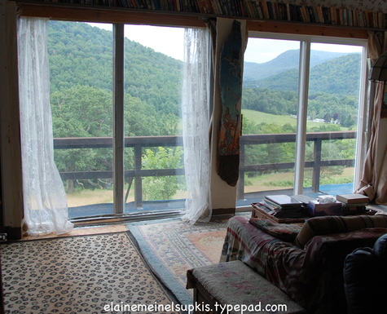
Here is the view when one walks through the house to the windows facing south.
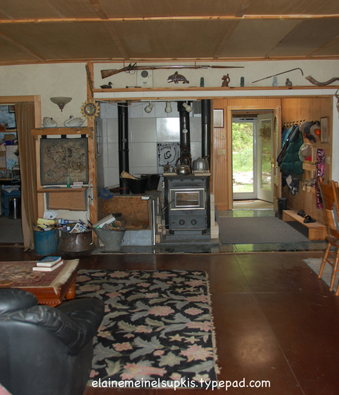
This is facing north to the front door. Our fireplaces for each floor pass through this area. We heat this house through passive solar energy from the sun rooms and with wood we chop up in our forest. My heart really goes out to everyone who will be punished brutally this coming winter as we see high and higher energy prices. For always, if the main source of energy goes up in price, they all rise in tandem. There is no escaping this system. Being too hot in summer is annoying. But freezing to death is a certainty if we have no energy sources and are bankrupt. I worry about this in general for the good people around me in this community are already preparing for winter and everyone is planning to probably use wood since it is local.
But not everyone is in this situation where they can get cheaper energy. It is a lot of work, dealing with firewood, feeding the fires, cleaning the chimney, emptying the ash tray every day, chopping, cutting and stacking firewood, etc. But it beats having no money.
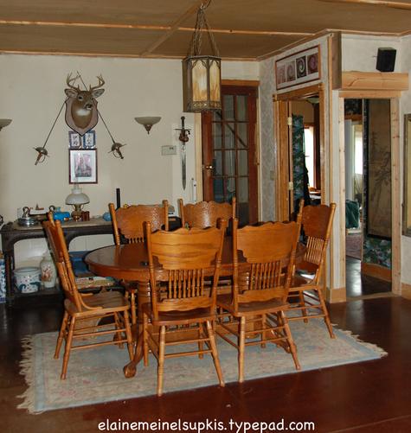
This is facing east to the dining area and bedroom. Every room on this floor is set up so I can see my husband in bed no matter if I am in the office, living room, kitchen, bathroom, whatever. This is why the bedroom has not one but two doors. This house has no hallways because of the need to see directly into all rooms from the center. This was a deliberate design my son and I developed when my husband was injured at work.
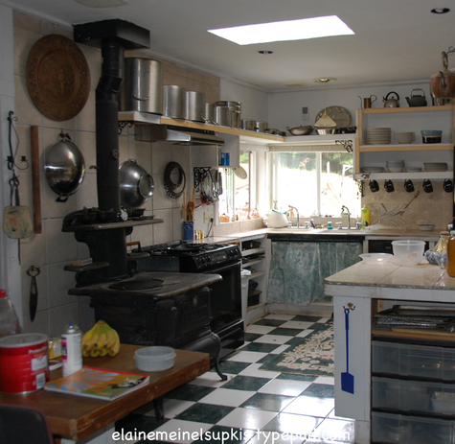
Here is the kitchen. I got the Victorian wood stove from an RPI student who had damaged it by burning things too hot. We rebuilt it and I have cooked on it for nearly 20 years now. It only cost $50. Like much of the things we have, we got it because it was damaged. This is true of many items here. Also, when businesses go bankrupt or redesign their stores, I go haunt the back docks to pick up many wonderful things. It pays to be very sweet to the people who work so hard at these places. I will never forget when the GE president of Home Depot took over and ordered the staff to never give anything away.
I was furious. I wasn't the only person who was irritated by this. Instead, Home Depot had to spend money to get rid of stuff! Then, we made deals with the guys hauling away Home Depot junk and they would let us root through it before they removed it. They didn't care. They got paid anyway! And of course, Home Depot is now in deep trouble thanks to this idiot who is now destroying Chrysler.
The sinks in my kitchen, for example, were Home Depot throw-aways. The tiles on the floor were from a discontinued series and so I used the phone and got all the Home Depots in a 100 mile radius to give me the left over stocks which were only a dozen or so tiles a store but with 20 stores, this came to more than enough tiles! Again: talking nice pays big time.
The sliding glass doors were all 'damaged' and rejected by builders. Bargain Outlet then buys them enmass. They let me know if they got lots of bad ones. Over the years, I have collected about 15 of these doors from them, all less than $75 each, often for only $20 each! Three of the doors were free!
To build the floors of this house, I got an entire shipment of 2"x12"x 12' lumber because a builder rejected the load. Since I was always nice to the people delivering this wood, they simply drove to my mountain and gave it to me for the cost of carrying it! So I have very strong floors. Not 5/8th inch plywood.
Building things is a social process. Hobnobbing with all and sundry pays off, hugely. Often, when I found building materials I didn't need, I passed them onwards to others.
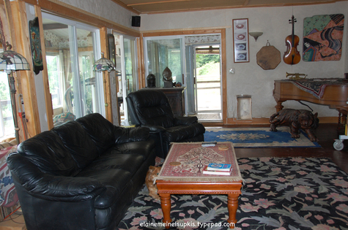
And the livingroom, facing the sliding doors to the side deck where we eat all summer long. The grand piano lived with us in the tent complex for ten years. We shall visit the tent complex in the next story. It is a sad and yet happy story. It is very painful, looking at the ruins of that earlier home.
Back to the outside:
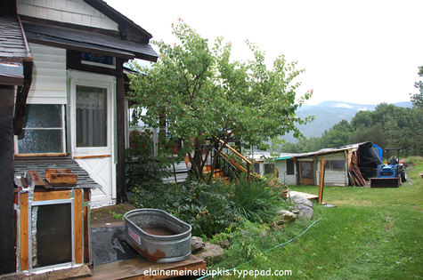
The dogs have their own door which goes into the west sunroom. This is facing west and we can see the sheds which used to be Sparky's stall but now is used for equipment storage. The chickens still live in the building's other half.
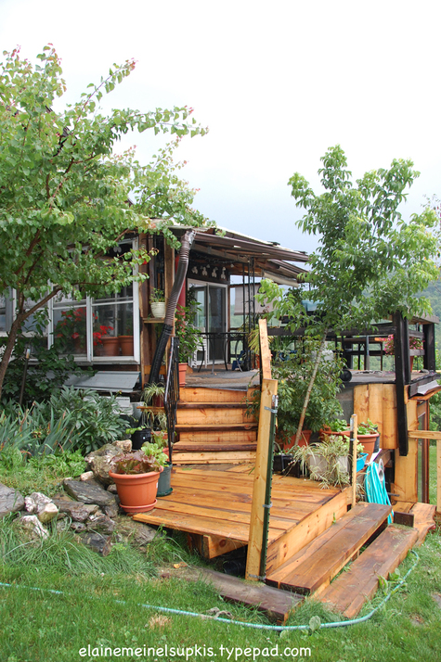
This is the deck. Nearly all the wood to make this were milled here on the mountainside over the years. Chip and Dale, our ox team, used to haul huge logs from up above to the mill and then John, a dear friend, would turn these into timbers and planks as we worked in harmony, pushing, pulling and using huge steel levers to jerk giant trees into the cutting track.
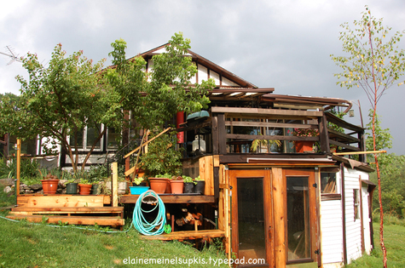
Facing east, we can see the lower levels where the tractor and backhoe are parked for the winter. The doors came from a Victorian house in Troy, NY. Another freebie. As are many parts of this system like most of the ironwork, for example. I highly recommend dumpster diving. It is quite profitable. Just wear good shoes and use gloves.
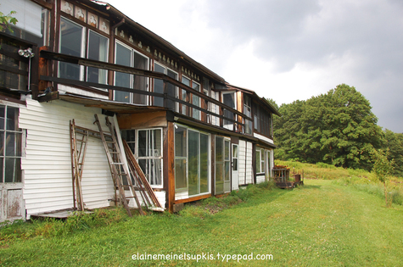
As I get free building materials, the south side of the house morphs and grows. Nearly everything in this picture is scavenged materials or grew on this mountain.
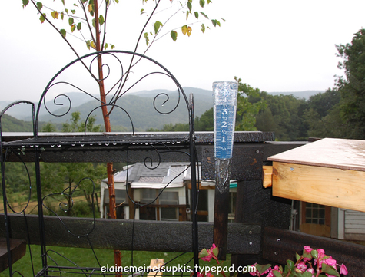
Just had to include the rain gage. We were very happy to see this small but very dangerous storm get shoved to the east. In the 19th century, a storm like this one that also formed right overhead in this valley, didn't move and it dumped over 10" of rain in less than three hours. It destroyed all the houses along a normally quiet stream on Plank Road.
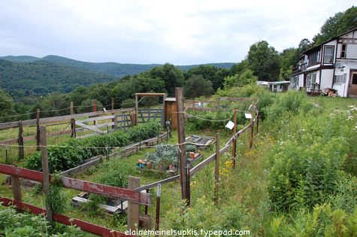
Everyone is gardening this year! And no wonder. It is a great way to save money. But the deer and rabbits and woodchucks attack the gardens. The dogs and cats are supposed to patrol but they get lazy and critters get in. The fence surrounding this garden was made from old barn boards I scavenged from a neighbor's old barn. With screw guns, putting this sort of bizarre structure together is easy. The string around the top has old tin plates which clank in the wind. This scares off the deer. I highly recommend this. An old, old man in the village told me about this and it works. When one needs to know esoteric stuff, going to very old people is VERY rewarding. They are all treasures! To be cared for because of this.
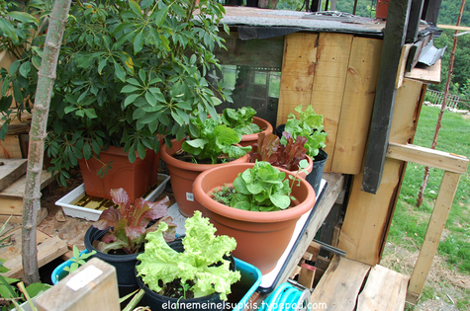
I collect discarded pots and have quite a few. I prefer to grow things like lettuce in pots because I can wander out of the kitchen and onto the deck and pick leaves at leisure. These are tender, wonderful leaves quite a bit nicer than in the store. Anyone can grow lettuce in pots! Just put them in a sunny window and water them. Or if there is any outdoors, put the pots in strategic places and then eat like a rabbit!
Next: the precursor to the house we built. The Tent Complex.
Email this post
Culture of Life News Main Page

Choose a language to translate this page!
July 11, 2008 | Permalink

TrackBack
TrackBack URL for this entry:
http://www.typepad.com/t/trackback/763647/31125690
Listed below are links to weblogs that reference Big Thunderstorm Downpour On My Mountain:

Comments
Wow, Elaine! Beautiful home with a wonderful view.
I can tell by looking at it that a lot of work is still involved in caring for it, but that is part of owning a home.
Posted by: DeVaul | July 11, 2008 at 05:34 PM
Very nice home, Elaine! Thanks for sharing. I'm sure yours will last many years beyond the particle board and vinyl clad crap that dominates the modern subdivisions of North America that are artificially and overly/overtly-inflated in price.
I'm jealous that you can grow things, collect rainwater and do all sorts of things us citydwellers, due to draconian bylaws, cannot do. They raise a stink if you want to do something as simple as to use a clothesline to dry clothes after washing them for pete's sake. And that's just the neighbours.
Love the kitchen.
Posted by: Blunt Force Trauma | July 11, 2008 at 05:57 PM
I have six water collectors. They have wooden tops to them except for the one in the dog door photo. I was using that tub to put transplanted trees into while digging new holes for them.
The lids keep the water pure and clean, by the way! In some NY communities, people MUST use 'rain barrels' by law to prevent flooding! That was due to researchers figuring out how to do this safely.
Good lids are the biggest key to making these work.
Posted by: Elaine Meinel Supkis | July 11, 2008 at 08:39 PM
What a beautiful dream to build your own independent lifestyle where you have freedom to think, do and love to your heart's content.
I think back 2000 years ago when families lived this type of independent lifestyle of love, faith and hard work.
Then the tax collectors came and demanded their money, animals or children. Pretty soon they were enticed into the Babylonian (wage slavery) market and the rest is history. 2000 years of perfecting this trick. As a builder of computer systems to scientifically manage and eliminate wage slavery I see how it works from the inside.
It pays well as we can see in this next article...
http://www.hudsonvalley.org/content/view/12/42/
Kykuit, the Rockefeller Estate
Kykuit is a preeminent Hudson Valley landmark. For architecture, remarkable gardens, art, history, and spectacular scenery, a trip to Kykuit is simply amazing.
This hilltop paradise was home to four generations of the Rockefeller family, beginning with the philanthropist John D. Rockefeller, founder of Standard Oil. His business acumen made him, in his day, the richest man in America. Now a historic site of the National Trust, this extraordinary landmark has been continuously and meticulously maintained for almost 100 years.
Your tour will take you to the main rooms of the six-story stone house. Then you will move on through the expansive, terraced gardens containing Governor Nelson A. Rockefeller's exceptional collection of 20th-century sculpture. Artists represented include Pablo Picasso, Henry Moore, Alexander Calder, Louise Nevelson, and David Smith, among many others. The private, underground art galleries with Governor Rockefeller's collection of Picasso tapestries, and the cavernous Coach Barn, with its collections of classic automobiles and horse-drawn carriages, are also part of the experience.
On each tour, your guide will share many stories that highlight the lives of Rockefeller family members and their contributions to philanthropy, conservation, business, government, and the arts.
Your choice of several tour options allows you to tailor a visit that appeals to your interests and your available time. Each tour begins at the Visitor Center at Philipsburg Manor, where you'll board a shuttle bus for a short ride to the estate
Posted by: GK | July 11, 2008 at 09:27 PM
An estate built by servants. Yup.
Huge houses are a nightmare to maintain and run. I have run these. Yuck. My house is just the right size. And easy to run, actually. Unlike the house in the Rockefeller story.
Posted by: Elaine Meinel Supkis | July 11, 2008 at 09:47 PM
Excellent Elaine. I have visited dozens of alternate homes in australia and it was a great thing to be invited on a virtual tour of yours. Fantastic work.
Posted by: Kevin McKern | July 11, 2008 at 10:17 PM
Thank you, Kevin. The funnest part about the house is the 12 doors we have. Locking up takes time, of course. But on nice days, all 12 doors are open and it is wonderful.
I never expected to have this happen. The doors are quite accidental.
Posted by: Elaine Meinel Supkis | July 11, 2008 at 10:27 PM
Elaine, truly amazing! This and the next post embodies what I have always perceived and loved about the American spirit. You lived it. You built it. From the ground up. That takes a whole lot of LOVE. I am proud to be in the same genus as you.
I know a bit about construction, having participated in building two home's and a large 500,000 sq.ft. Center. But to do what you did almost single handedly has my respect.
If I may suggest, start writing a book on this, seriously. Title it, "YES YOU CAN". Spread the word to people on how to survive, how to build, how to source, how to keep hope. Tell them, tell me.
I would be surprised if it did not make the best seller list.
Posted by: Carli | July 11, 2008 at 11:18 PM
Thanks for sharing, Elaine. Your tractor appears to be a New Holland? (I opted for the Kubota, as I have had tremendous luck with all machinery that originates in Japan - including three Toyota trucks)
I also look forward to a great simple pleasure of mine: burning wood this winter. Although I did lock in at the bargain basement price of $2400 for 500 gallons of red-dyed diesel, to ensure that I have hot water..
Kind regards from 90 miles due east.
Posted by: Clymer | July 12, 2008 at 07:15 AM
The tractor is an old Ford from a farmer who died and his widow sold it to us. He also gave us his bee hives for free. The old farmers here abouts are wonderful people.
Posted by: Elaine Meinel Supkis | July 12, 2008 at 08:35 AM

